**PureCloud OpenAPI Integration with NCC, NBF**

Part 1. Preparation in PureCloud Environment

For integration we need further things:

1. *clientId* - OAuth client ID
2. *clientSecret* - secret for OAuth client
3. *integrationId* - ID of integration used for ChatProxy
4. *secretSignatureToken* - signature token for integration
5. *environment/Host* - organization AWS Region

1,2. How to get “***clientId***” and “***clientSecret***”

* 1. Open **Admin Home** menu



1.2 Create OAuth client with **Client Credentials** grant type

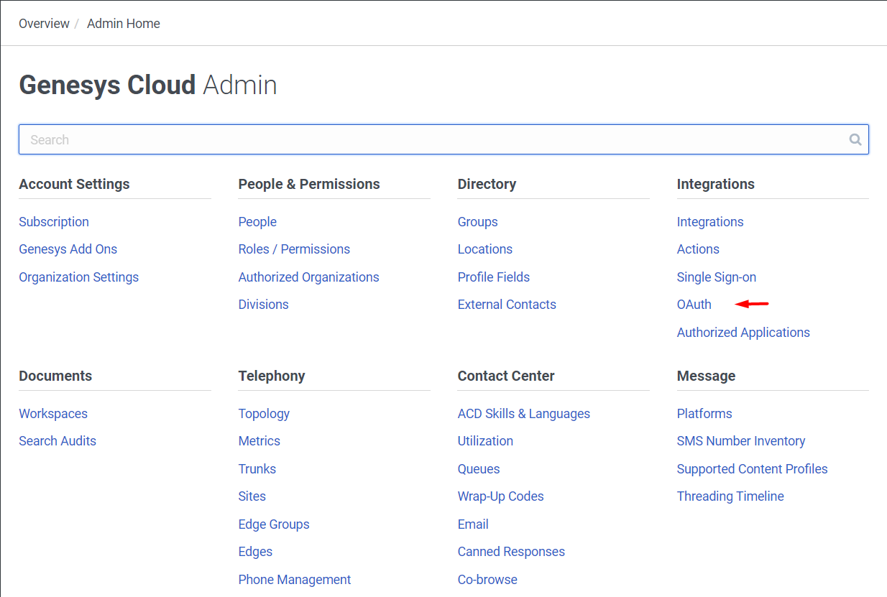

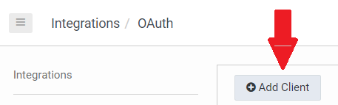

1.3 Choose your OAuth client from the list to see it’s details

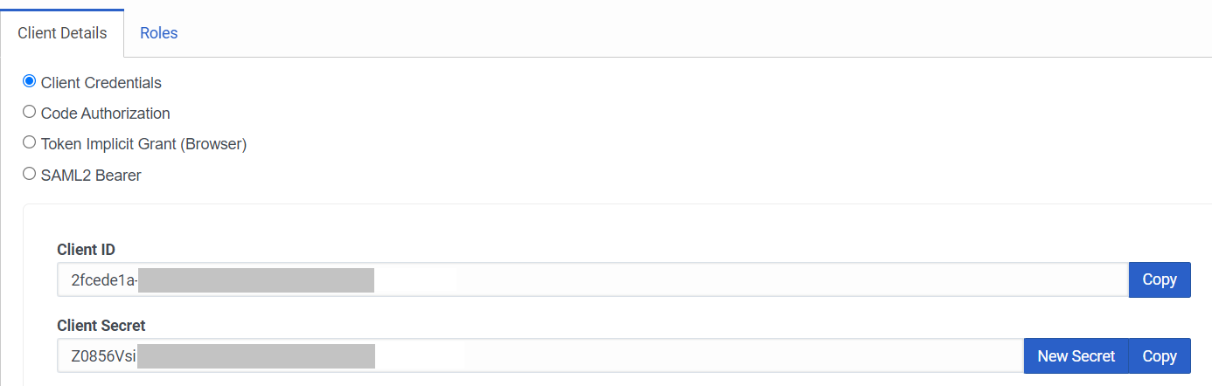

1. How to get “***integrationId***”

3.1 Add created OAuth client to **Admin > Authorized Application** with conversation and messaging scopes and assign to it Role with:

* conversation:message:create
* conversation:message:receive
* conversation:webmessaging:create
* messaging:integration:all permissions

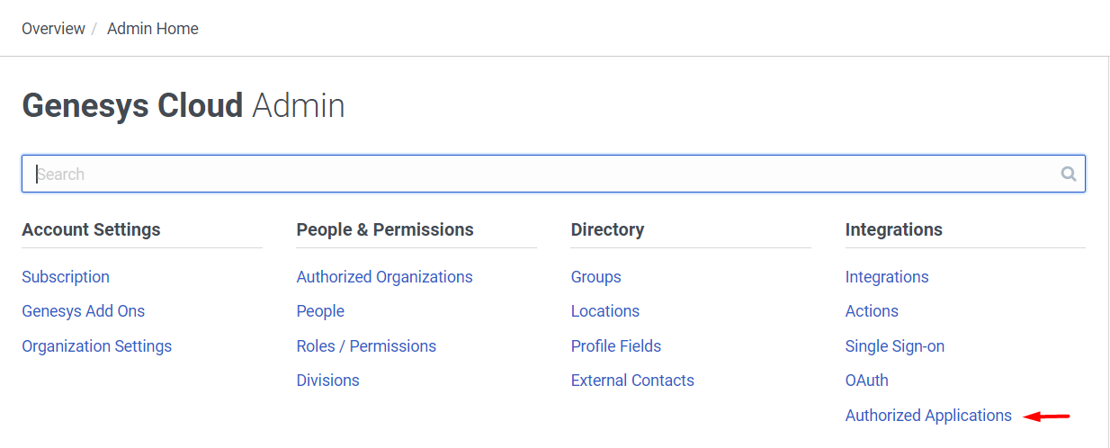

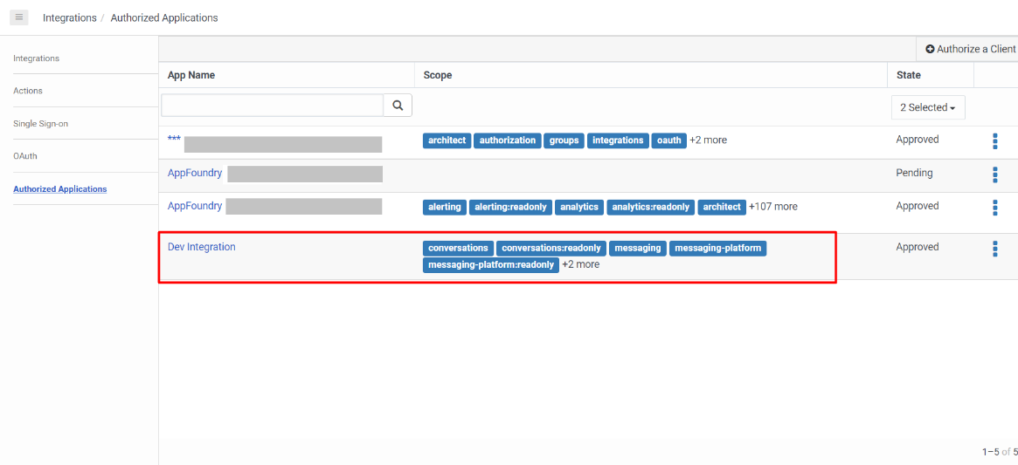

* 1. 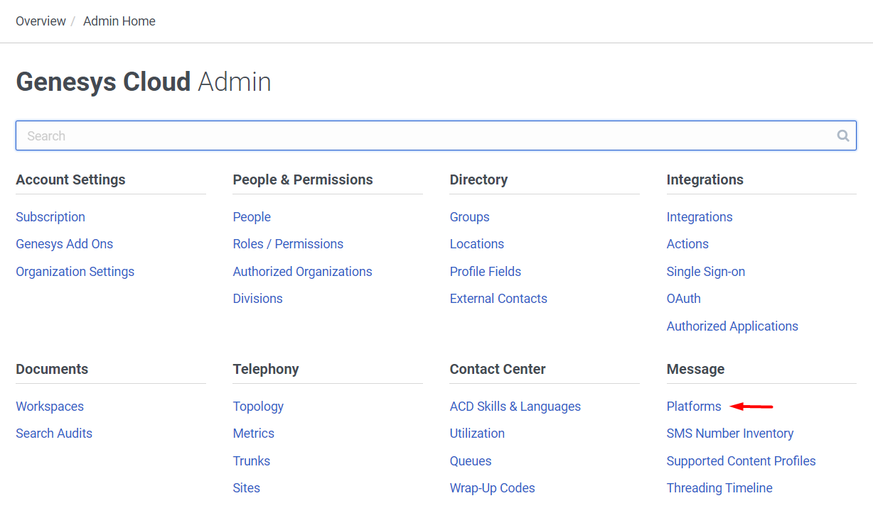Create integration using [API call](https://developer.genesys.cloud/api/rest/v2/conversations/#post-api-v2-conversations-messaging-integrations-open) or in GUI go to **Admin** > **Message** > **Platforms**, and choose **Add Platform** > **Open Messaging**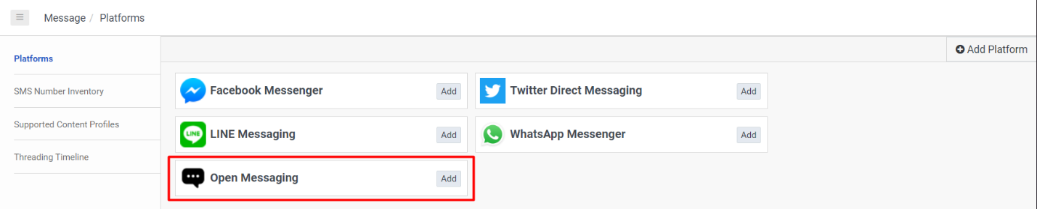
  2. 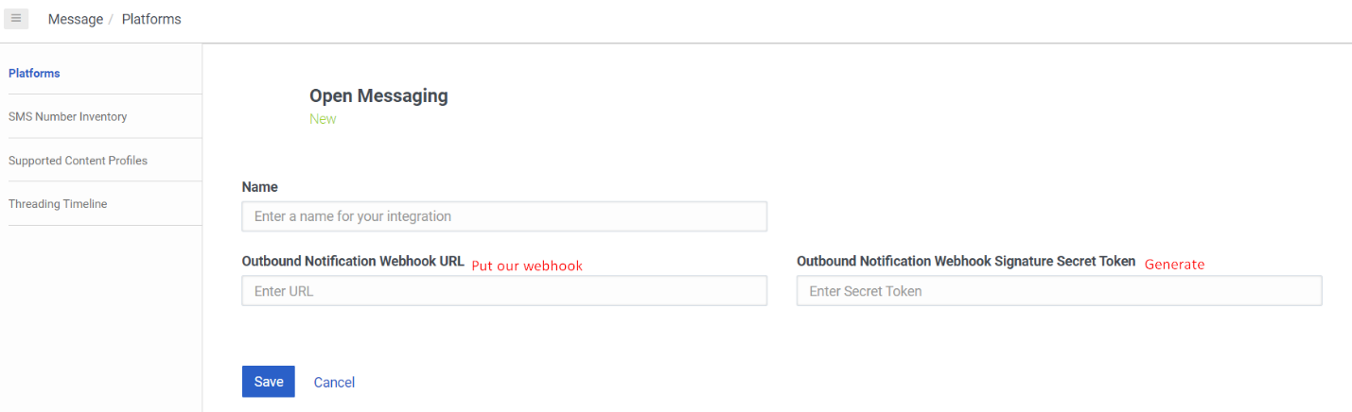Give a name for your integration. Put our webhook. Generate a token and send to us.
  3. Get integration ID: if integration was created with API call, ID can be found in response object; or use [API call](https://developer.genesys.cloud/api/rest/v2/conversations/#post-api-v2-conversations-messaging-integrations-open) to get list of integration and get ID:
     1. Obtain the *Access Token* for next request ([link](https://developer.genesys.cloud/authorization/platform-auth/use-client-credentials)):

**POST** /oauth/token HTTP/1.1

Host: login.mypurecloud.ie

Authorization: Basic BASE64(<client_id>:<client_secret>)

Content-Type: application/x-www-form-urlencoded

grant_type=client_credentials

*Host depends on your PureCloud AWS Region

* + 1. Obtain your IntegrationID from the next request:



Request example:

**GET** /api/v2/conversations/messaging/integrations/open HTTP/1.1

Host: api.mypurecloud.ie

Authorization: Bearer <token>

*Host depends on your PureCloud AWS Region

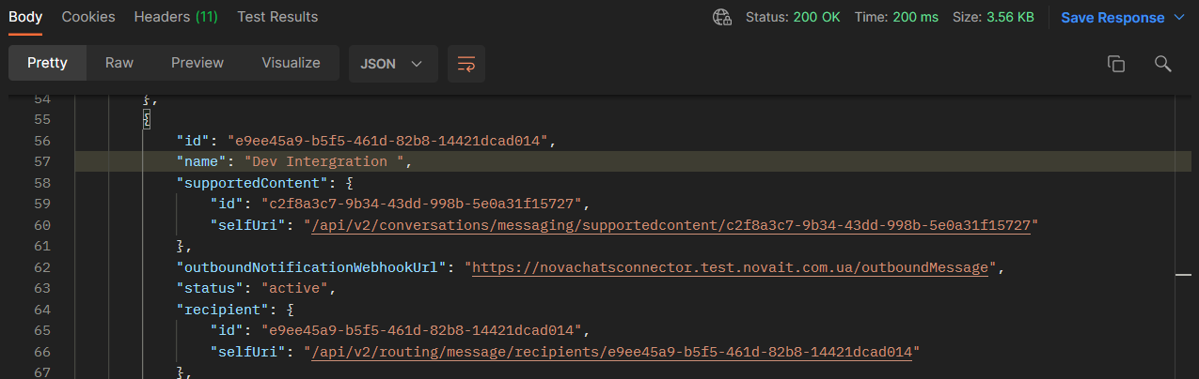Response example:

1. How to get “***secretSignatureToken***”

As was shown on a figure in **3.3**, it is generated manually by user and needs to be in the corresponding field in GUI.

(**Admin** > **Message** > **Platforms**, and choose **Add Platform** > **Open Messaging** > **“Signature Secret Token”** field).

1. How to get “***environment/Host***”

The AWS Region can be found according to [this](https://help.mypurecloud.com/articles/aws-regions-for-genesys-cloud-deployment/) tablePart 2. Preparation in PureCloud Architect

1. Create **Inbound Message** flow in Architect.

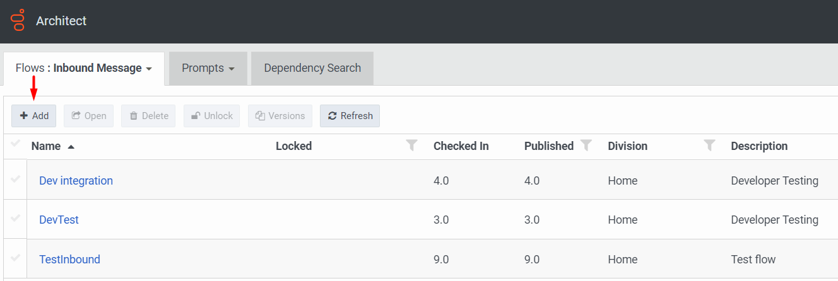

1. 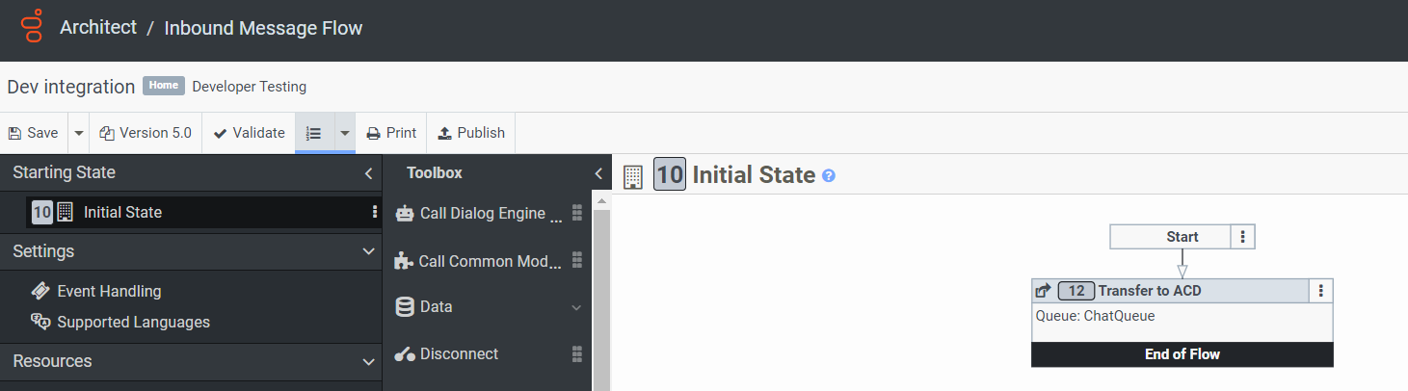Modify Flow as you need. For example the simplest Routing to Chat Queue you can see on screen below. Validate and Publish new flow.
2. Connect 'Inbound Message' flow to integration in **Admin > Routing > Message Routing**

